VCSS Capstone Project

What is a Capstone Project?

A capstone project, also known as a culminating project or experience, or senior exhibition, amongst other terms, is a project that will allow you to demonstrate your learning using an area(s) of interest as the basis for the project. Ideally, this would be in an area you are passionate about and anticipate you may pursue after graduation.

The capstone project is a requirement for Career-Life Connections and for graduation.

Over the next few months you will design, assemble, and present a capstone project to an audience to demonstrate personal learning and achievement (in and out-of-school), growth in the core competencies, and a reflection on your post-graduation plan. (BC Ministry of Education)
Make this project fun, make it engaging, but make it manageable, as it will be due after Christmas.

Your Capstone Project has five parts:

- Preparation: Self-assessment and critical analysis
- Proposal (approved by Career Life Connections teacher advisor)
- Project and logbook
- Presentation
- Reflection

Assessment and Grading

Your Capstone Project is worth 52% of your overall grade. The remaining 48% will be split equally between the three units 16% each).

Each of the five parts of your Capstone Project must be completed to a passing standard. You will be given the opportunity to redo your work until it meets that standard.

The Five Parts

1. Preparation: Self-assessment and critical analysis
In order to determine how you would like to represent yourself and your learning journey to a relevant audience, students engage in two preparation experiences under the guidance of their staff advisor: self-assessment and critical analysis.
Students reflect on their Core Competency development and identify key insights about their learning journey (past, present, and possible futures) by drawing from the following:
- learning experiences and accomplishments from multiple areas of learning at school and in other contexts
- career-life development conversations with mentor(s)
- collected demonstrations of authentic career-life evidence
- reflections about Core Competency development
- career-life exploration – substantive experiential learning experience
- assignments, peer collaborations, inquiry learning, and so on, pursued during Career-Life Education and Career-Life Connections coursework

- Task: Complete the Core Competencies Reflection Sheet

2. Proposal
Use the attached proposal and planning form to help you generate your topic and complete your proposal. Your proposal must be approved and signed by your Career Life Connections teacher advisor before beginning your project.

Criteria for selecting a topic:
- Your project should reflect at least 30 hours of work
- Your topic must be important to you – an area of passion, something that excites you
- Your project must explore something NEW to you, but can also EXPAND on something you can already do, or delve deeper into something you may already have some knowledge in
- You cannot “double dip” (ie. Submit an assignment – like the English 12 research paper – used in a different course)
- Your topic (ideally) should relate to at least one of your future endeavors (you can be creative in linking the two)
- You don’t necessarily have to succeed or fully meet your goal, however, you must be able to articulate the successes, challenges, areas for further development and most important your learning and growth along this journey
- Your project must be manageable yet challenging
adapted from: Moscrop Secondary, Burnaby, BC

- Task: Complete the Proposal and Planning Form; Get Teacher Approval

3. Project and Logbook
Begin the research necessary for your project. Be sure to do enough research, but don’t get bogged down in this stage.
Once you have enough information, begin your project.
Remember to record what you have done, and the time spent doing it, in your logbook as this will be essential in establishing that you have spent at least 30 hours on this project.

- Task: Complete your Project and Logbook

4. Presentation
A presentation date will be set for all students to present their projects after Christmas, but before the exam week. You may invite people to come and see your project if you wish.
Your project may be presented in a number of ways, dependent upon the type of project you have completed. You may present a display, a PowerPoint, a YouTube video, spoken word, demonstration, etc.
Further information will be presented closer to the date of presentation.
Your presentation should touch upon the following:
- Give a thorough introduction of yourself. Who are you and how does this project represent your interests?
- How does this project relate to your post graduation plans and options?
- How does this project relate to your preferred future careers or career areas? Options
- Has this project reinforced or caused you to change your plans?

adapted from: Moscrop Secondary, Burnaby, BC

- Task: Present your Project

5. Reflection
You will reflect on your project and address a series of questions. You may answer the questions one by one, or integrate them in to an essay style response.

You will reflect upon things such as:
- discuss the journey you experienced & what you learned.
- Identify where you are now in this journey. What new goals/questions will you set/explore as you move on? (can be an extension of your Capstone or can be a brand-new goal)
- What did this process teach you about pursuing goals & lifelong learning? (Highlight how you’ve demonstrated through your Capstone project, that you are a lifelong learner).
- What impact has your Capstone experience had on you?
- How will you approach a similar assignment in the future?
- What knowledge have you gained that you feel will be the most beneficial?
adapted from: Moscrop Secondary, Burnaby, BC

- Task: Complete your Personal Reflection; hand in to your teacher supervisor
VCSS Capstone Project

Part1

Preparation: Self-assessment and critical analysis
Core Competencies are at the centre of the curriculum redesign in BC. Core Competencies are sets of intellectual, personal, and social and emotional proficiencies that all students need to develop in order to engage in deeper learning. The Core Competencies include thinking, communication, and social and personal competencies. (BC Ministry of Education)
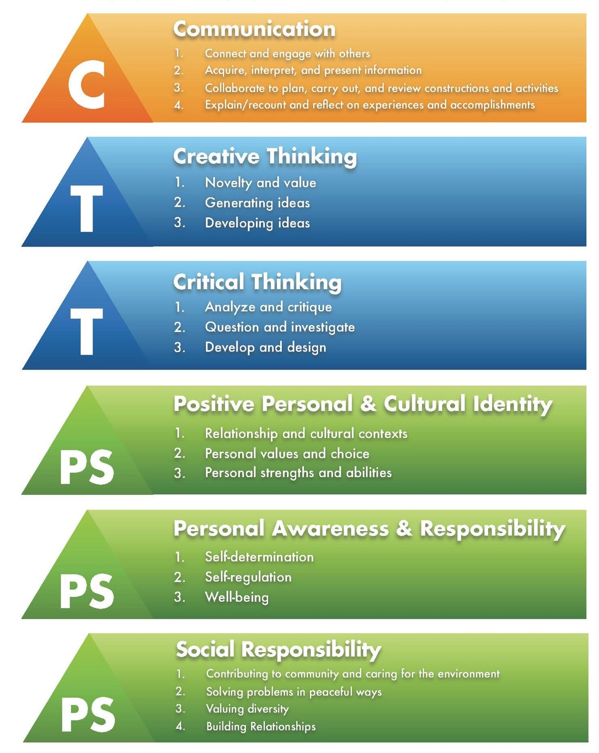

Name: _______________________________________________

Core Competencies Self-Assessment

Communication
- Connect and engage with others (to share and develop ideas)
- Acquire, interpret, and present information (includes inquiries)
- Collaborate to plan, carry out, and review constructions and activities
- Explain/recount and reflect on experiences and accomplishments

What I do well in this area: (I am good at…./ I can…./

Evidence of this strength:

What I need to work on: (I can get better at…)

Evidence that this is an area for growth:

My plan for growth in this area:

Creative and Critical Thinking
Creative Thinking:  - Novelty and value  - Generating ideas  - Developing ideas | Critical Thinking:  - Novelty and value  - Question and Investigate  - Develop and design
What I do well in this area: (I am good at…./ I can…./

Evidence of this strength:

What I need to work on: (I can get better at…)

Evidence that this is an area for growth:

My plan for growth in this area:

Personal and Social
Positive Personal and Cultural Identity:  - Relationships and cultural contexts  - Personal values and choice  - Personal strengths and abilities | Personal Awareness and Responsibility:  - Self-determination  - Self-regulation  Wellness | Social Responsibility:  - Contributing to Community and caring for the environment  - Solving problems in peaceful ways  - Valuing diversity  - Building relationships
What I do well in this area: (I am good at…./ I can…./

Evidence of this strength:

What I need to work on: (I can get better at…)

Evidence that this is an area for growth:

My plan for growth in this area:

adapted from North Vancouver School District

VCSS Capstone Project Proposal

1. Explore Some Ideas

You may already have an idea of what you want to do. you may have no idea at all, or you may have an idea that needs some ‘fine-tuning.’

To help you generate some ideas, or to narrow down others, explore these questions.

- What are you interested in?
- What would you like to improve? a skill? a talent? time organization?
- What do you need to learn? before you enter post-secondary? to pursue the career of your choice?
- What are you passionate about?
- What are you perplexed by? what can you do to solve or change that?
- What are you afraid of in terms of personal growth – speaking up in class? public speaking? working with others?
- What are you curious about?
- What do you or others want and expect from you? That is, what do you need to do to meet your goals?
- What makes you angry about society or our community? – what do I want to see changed?
- What is something you think would really make a difference? in your life? in the lives of others? in our school? in our local community? in the global community? What can you do about it?

Use to bottom of this page and the back of this page to brainstorm some ideas and responses to these questions.

Brainstorming and question response space.

2. Narrow It Down

Circle the top three ideas on your brainstorm and question list. Carefully choose the one the speaks to you most. Don’t be afraid to ask your friends and family for help in deciding!

Make sure you project:
- is manageable yet challenging
- is exciting (you will be working on this for a minimum of 30 hours)
- has necessary resources available (people to talk to, time, space, physical items)

3. The Proposal

Proposed Project: ______________________________________________________________

Tell why or how you are interested in this project. How is this topic relevant to you? To your life? Why is it important to you? What do you hope that exploring this topic will do for you? Explain why it is meaningful. How will this inform your career-life choices? Convince me of why this topic is important/special/relevant/meaningful to you!

__________________________________________________________________________________________________________________________________________________________________________________________________________________________________________________________________________________________________________________________________________________________________________________________________________________________

Explain what your current knowledge/skill level is with your topic. Do you have any current experience with this topic? (What do you already know, already know how to do, or already understand about your topic?). (It is OK for your Capstone to ADD to something you’ve already begun, but you must be able to demonstrate what NEW learning will have occurred in your Capstone process.) What is your base-line knowledge/experience with this topic?
__________________________________________________________________________________________________________________________________________________________________________________________________________________________________________________________________________________________________________________________________________________________________________________________________________________________
Explain what you hope to accomplish with this project; what new learning will occur. What do you hope to achieve? What do you hope to learn/understand, or be able to do? For example: If you are developing a skill, describe the level of skill you would like to achieve.
__________________________________________________________________________________________________________________________________________________________________________________________________________________________________________________________________________________________________________________________________________________________________________________________________________________________

adapted from Moscrop Secondary School, Burnaby BC and Guildford High School. Guilford Connecticut

Explain how you will go about doing this project. Outline as many action steps as you can to support your goal and work towards completing your project. Include how you will come to know pertinent information, what you will do to explore your topic, and then how you will make sense of what you’ve done.
__________________________________________________________________________________________________________________________________________________________________________________________________________________________________________________________________________________________________________________________________________________________________________________________________________________________
What research will you use to help you during this project? Include books, articles, experts in the field, materials, internet and any other sources of information you may cite.
__________________________________________________________________________________________________________________________________________________________________________________________________________________________________________________________________________________________________________________________________________________________________________________________________________________________
In addition to your Career Life Connections teacher advisor, what mentor(s) will be available to help you achieve your goal and how will they be involved?
________________________________________________________________________________________________________________________________________________________________________________________________________________________________________________________________________________________________________________________________________
What problems might you anticipate?
__________________________________________________________________________________________________________________________________________________________________________________________________________________________________________________________________________________________________________________________________________________________________________________________________________________________
This Capstone Project proposal is: CLC teacher advisor signature:
approved
not approved (see notes, amend, resubmit) __________________________________

adapted from Moscrop Secondary School, Burnaby BC and Guildford High School. Guilford Connecticut

VCSS Capstone Project
Log Book

You may use this log book, or you may create one of your own, as long as it contains similar information.

Date | Time Spent | Description of activities | Resources used/people consulted
Sept 3 | 45 minutes | Reading website; taking notes | researchcentral.com  iwantajob.com

VCSS Capstone Project
Personal Reflection

You will now write a personal reflection about your capstone project and the process.

Following are some questions for you to consider when writing your reflection. You do not need to answer each one of the questions, they are simply provided to help focus and guide your thinking.

Begin your reflection by describing your project and explaining why/how you chose it. Next, briefly describe what you did to complete your Capstone. The rest is up to you!

- How did the knowledge and skills you acquired at Vanier Catholic Secondary School assist you with your project?
- Now that it's over, what are your first thoughts about this overall project? Are they mostly positive or negative? If positive, what comes to mind specifically? Negative?
- What went right? What went wrong? How did you solve the problems you encountered?
- Are you proud of your project? Why or why not?
- What led you to your topic?
- What did you initially set out to do? In what ways did your goals change along the way?
- What gave you the biggest sense of accomplishment?
- What were some of my most challenging moments and what made them so?
- What would you have done differently?
- What did you expect this project to do for you? Did it meet your expectations?
- What were some of the most interesting discoveries I made while working on this project? About the problem? About myself? About others?
- What did you learn about the world or your topic? How did the project open your eyes to a new perspective, career option, or life experience?
- How did an adult/mentor help you achieve your goal?
- How could this project have future implications for you at college or in your choice of employment?
- How will you use what you've learned in the future?

Finally, we want you to honestly reflect on the effort and energy you put into this project: Did you take it seriously? Was it exciting to work on something of your choosing, etc.?

